22 December 2006 The Weekly Bulletin of Rotary Club of Kathmandu Mid-Town Bc # 25 of 2006-07
Rotary Club of Kathmandu Mid-Town
Breakfast Chatter




District : 3290 Web: www.rotarymidtown.org.np Club Id : 26776

DECEMBER IS ROTARY FAMILY MONTH

How do we involve our own families in Rotary?
~ At special family oriented social events
~ At club meetings for special programs
~ Assistance at fund raisers
~ In community service projects
~ Hosting Youth Exchange and GSE teams

Talk program at the Club meeting on Friday, 15 December 2006.
Guest Speaker Ms Greta Ratliff spoke to the Club members on what she has been doing in Nepal for helping deaf children by providing custom-built hearing aids.
She informed that Welfare Society for the Hearing Impaired in Nepal is assiting her in her efforts to provide hearing aids to over 2,000 children in 2007.

Weekly Meetings and Programs :
Date | Program/Speaker | Program/Topics of Presentation
22 Dec 2006 | Club assembly | Club assembly
29 Dec 2006 | Dr Banu Sharma | Dental surgery
5 Jan 2007 | Pratyous Onta

Friday, 22 December :
This Friday is the Club assembly, the third in the year 2006-07.
There is no need to remind club members to attend the club assembly since every member is aware, presumably, that this is the time for reviewing programs, projects and activities of the club. Attendance and participation at club assembly will evidently show your effective involvement and seriousness towards club affairs and activities.

Eye Camp at Hetaura :
The annual eye camp is going to be held in Hetauda, scheduled from 7 to 11 January 2007. Annual eye camp at Hetauda is Kathmandu Mid-Town's pride program. Mid-Towners will go to Hetauda and help, in whatever possible way, the camp operation with true spirit of Rotary's ideal of Service Above Self.

Air Pollution :
Air pollution is killing more than half a million people in Asian cities each year and shows no sign of improving as urban centres expand, studies by the Asian Dev Bank show. Air pollution had reached "serious levels" in several Asian cities - Beijing, Dhaka, Hanoi, HoChiMinh City, Jakarta, Kathmandu, Kolkata, New Delhi and Shanghai - with the problem worsening due to increased urbanization and motor vehicles. In many cities, the concentration of air pollutant known as fine particulate matter or PM10 exceeds 70 micrograms per cubic meter. WHO guidelines say this should be lower than 20 mg per cubic meter. Emerging Asia has rather low levels of personal motorized transport, in many cases comprising mainly motorcycles, but these levels are likely to increase drastically as incomes in these countries grow and the urban populations expand. ADB conference in Indonesia issued a call for a review of air quality standards and air pollution indices all over the region to make them more effective and more comparable to each other; improved fuel quality and emission standards for new vehicles as well as more strategies to control emissions from vehicles that are already on the roads. Other measures include promoting clean, alternative, renewable energy, encouraging the use of mass public transport systems and even promoting urban housing that lowers energy consumption and emissions.
Source: The Himalayan Times

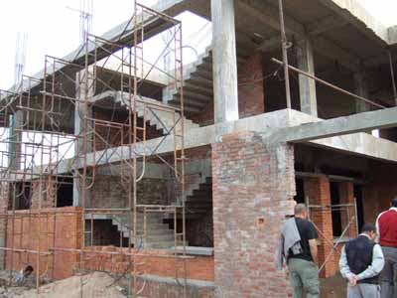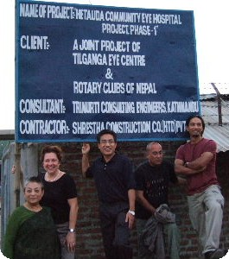
a) Hetauda Community Eye Hospital under construction; b) Mid-Towners witnessing project visit

On the occasion of Christmas Day the Breakfast Chatter editor sends his best Greetings
Merry Christmas
to all Club members, their spouses, children and all other family members

Merry Christmas : Click at the figure ⇩


A key idea of the family of Rotary is that it encompasses the family of every Rotarian — spouses, widows and widowers, children, and parents. Rotary was never designed to take club members away from their families. Instead, it should be a force that brings them together.
RI President William B. Boyd

22 December 2006 The Weekly Bulletin of Rotary Club of Kathmandu Mid-Town Bc # 25 of 2006-07

Editor: RR Shrestha, Club Service Director email: rryes@wlink.com.np

